**Setting up Anaconda Environment for Python**

Installing Anaconda on Windows

#### 1. Visit the Anaconda downloads page

Go to the following link: [Anaconda.com/downloads](https://www.anaconda.com/download/)

The Anaconda Downloads Page will look something like this:



#### 2. Select Windows

Select Windows where the three operating systems are listed.

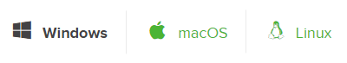

#### 3. Download

Download the most recent Python 3 release. At the time of writing, the most recent release was the Python 3.6 Version. Python 2.7 is legacy Python. For problem solvers, select the Python 3.6 version. If you are unsure if your computer is running

a 64-bit or 32-bit version of Windows, select 64-bit as 64-bit Windows is most common.

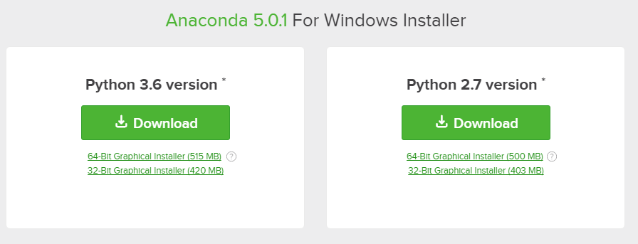

You may be prompted to enter your email.

#### 4. Open and run the installer

Once the download completes, open and run the **.exe** installer

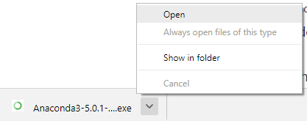

At the beginning of the install, you need to click **Next** to confirm the installation.

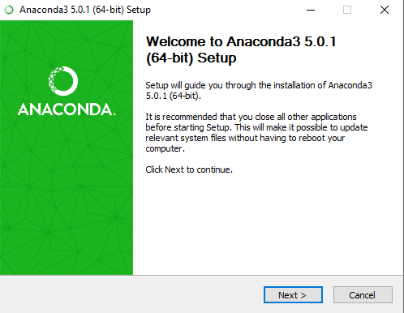

Then agree to the license.

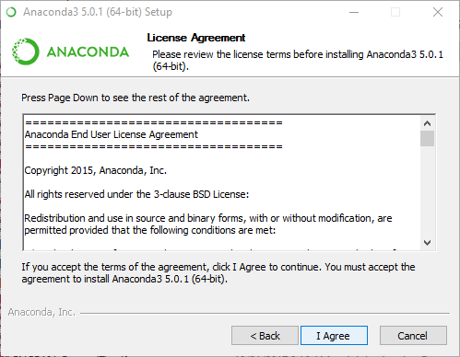

At the Advanced Installation Options screen, I recommend that you **do not check** "Add Anaconda to my PATH environment variable"

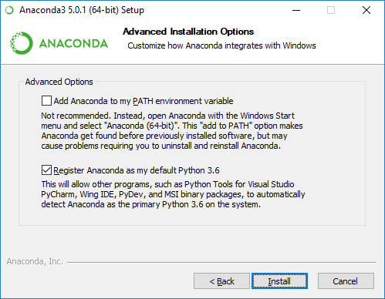

#### 5. Open the Anaconda Prompt from the Windows start menu

After the installation of Anaconda is complete, you can go to the Windows start menu and select the Anaconda Prompt.

At the Anaconda prompt, type

> python

Note the Python version. You should see something like Python 3.6.1. With the interpreter running, you will see a set of greater-than symbols >>> before the cursor.

